Nanobiotech Group, Industrial Biotechnology Div., National Institute For Biotechnology & Genetic Engineering, P.O. Box # 577, Jhang Road, Faisalabad, Pakistan. | Phone +041-2651475-9  Fax +041-2651472  Email: asmanano@gmail.com  URL:www.nibge.org
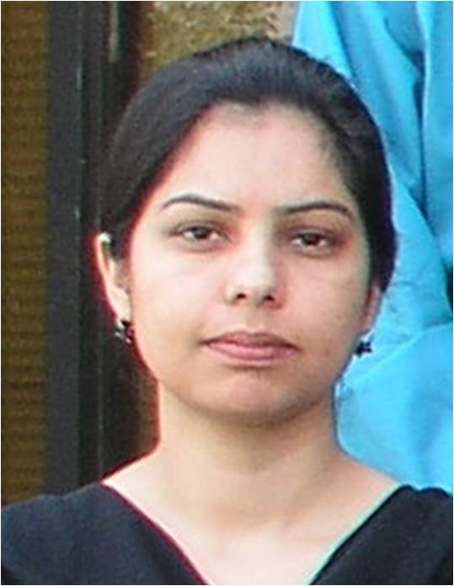
Asma Rehman
Personal Information
Father’s Name: Fazal-ur-Rehman
Date of Birth: 01-03-1978
Marital status: Married
Nationality: Pakistani
N.I.C.: 17301-1286720-2
Contact No. 0092-3339110984
Email: asmanano@gmail.com

Research Experience

- About four years of working experience as Researcher in Nanobiotechnology group, Industrial Biotechnology Division, NIBGE from July 01, 2006 to Feb 02, 2010. Currently I am working as Junior Scientist in the same group w.e.f. Feb 03, 2010. In this group, I have been involved in/completed the following research projects:

1: Use of microbially produced surfactants i.e; rhamnolipids for the preparation of metal (gold, silver, iron oxide etc) nanoparticles.
2: Self assembly of rhamnolipids for the synthesis of microfibers/nanofibers which have potential applications in nerve cells regeneration.
3: Use of biological templates such as rhamnolipid fibers and fungal hyphae etc. to organize metal nanoparticles into well-defined nanostructured materials.
4: Development of simple and new chemical approaches for the synthesis of metal (gold and silver) nanoparticles and explored their applications in PCR-based diagnostics to improve sensitivity and specificity of PCR for early detection of pathogenic bacteria.
5: Preparation of highly porous polyacrylamide beads/monoliths and their use as scaffolds to assemble metal nanoparticles (gold, platinum, palladium, and ruthenium) and hydroxyapatite nanomaterial to produce highly porous metals and metal nanoparticles-inorganic oxide composites for applications in catalysis and sensing.
6: Synthesis of functionalized metal nanoparticles like copper, zinc oxide, nickel etc and their environmental applications to remove toxic metals and organic compounds (such as phenolics) from wastewater.
7: Use of gold nanoparticles-based nanoprobes for HCV diagnosis.
8: Synthesis of selenium nanoparticles using single step simple strategies.

- Two years working experience as Research Fellow at Environmental Biotechnology Division, NIBGE from 01-04-2004 to 27-06-2006. During this period, I have been trying to work out biotechnological solutions to various environmental problems with special reference to monitoring and treatment of industrial effluents using various approaches such as biodegradation, phytoremediation and biosorption etc. Microbial production of rhamnolipids/biosurfactants was also established using frying oil and oil refineries waste material as sole carbon and energy source.

Academic Qualifications
- B.Sc. Chemistry, Botany and Zoology (1st Div.) (1998), University of Peshawar, Peshawar, Pakistan.
- M.Sc. Chemistry (1st Div.) (2001), Department of Chemistry, University of Peshawar, Peshawar, Pakistan.
- M.Phil. Biotechnology (1st Div.) (2004), NIBGE, Department of Biological Sciences, Quaid-i-Azam University, Islamabad, Pakistan.
- PhD Biotechnology (2013), NIBGE, Department of Biological Sciences, Quaid-i-Azam University, Islamabad, Pakistan.
Research Publications
1. Khan, W. S., Cao, C., Butt, F. K., Ali, Z., Nabi, G., Rehman, A., Ihsan, A., Tanveer, M., Aslam, I., Hussain, S., Usman, Z. and Mehmood, T. 2013. Preparation of single crystalline zinc nitride dandelion-like nanostructures; their photoluminescence and hydrogen absorption properties. Science of Advanced Matrerials. 5: 1-5.
2. Ihsan, A., Hussain, I., Khan, W. S., Rehman, A., Ghauri, M. A. Cao, C. 2013. Facile synthesis of metallized nanocontainers for the entrapment and controlled release of hydrophobic compounds. Materials Letters. 95: 78-81.
3. Khan, W. S., Cao, C., Butt, F. K., Ali, Z., Ihsan, A., Tanveer, M., Aslam, I., Nabi, G., Rehman, A., Mahmood, T. and Hussain, S. 2013. Preparation of highly pure CdSe hollow structures; their PL and hydrogen absorption properties. Materials Letters, 92: 263-266.
4. Khan, W. S., Cao, C., Aslam, I., Ali, Z., Butt, F. K., Mahmood, T., Nabi, G., Ihsan, A., Usman, Z. and Rehman, A. 2013. Single crystalline multi-petal Cd nanoleaves prepared by thermal reduction of CdO. Materials Research Bulletin. 48: 819-822.
5. Khan, W. S., Cao, C., Butt, F. K., Ali, Z., Usman, Z., Nabi, G., Ihsan, A., Rehman, A., Hussain, I., Tanveer, M. And Hussain, S. 2013. Hydrogen storage and PL properties of novel Cd/CdO shelled hollow mircospheres prepared under NH₃ gas environment. International Journal of Hydrogen Energy. 28(5): 2332-2336.
6. Rehman, A., Majeed, M. I., Ihsan, A., Hussain, S. Z., Rehman, S. U., Ghauri, M. A., Khalid, Z. M. and Hussain, I. 2011. Living fungal hyphae-templated porous gold microwires using nanoparticles as building blocks. Journal of Nanoparticle Research.13: 6747-6754.
7. Hussain, I., Hussain, S. Z., Rehman, H., Ihsan, A., Rehman, A., Khalid, Z. M., Brust, M. and Cooper, A. I. 2010. In situ growth of gold nanoparticles on latent fingerprints—from forensic applications to inkjet printed nanoparticle patterns. Nanoscale. 2: 2575-2578.
8. Rehman, A., Raza, Z. A., Rehman, S., Khalid, Z. M., Subramani, C., Rotello, V. M. and Hussain, I. 2010. Synthesis and use of self-assembed rhamnolipid microtubules as templates for gold nanoparticles assembly to form gold microstructures. Journal of Colloids and Interface Science. 347: 332-335.
9. Raza, Z. A., Khalid, Z. M., Khan, M. S., Banat, I. M., Rehman, A. Naeem, A. and Saddique, M. T. 2010. Surface properties and sub-surface aggregate assimilationof rhamnolipid surfactants in different aqueous systems. Biotechnol Letters. 32: 811-816.
10. Rehman, A., Raza, Z. A., Afzal, M. and Khalid, Z. M. 2007. Kinetics of p-nitrophenol degradation by Pseudomonas pseudomallei wild and mutant strains. Journal of Environmental Science and Health, Part A. 42: 1147-1154.
11. Raza, Z. A., Rehman, A., Khan, M. S. and Khalid, Z. M. 2007. Improved production of biosurfactant by a Pseudomonas aeruginosa mutant using vegetable oil refinery wastes. Biodegradation. 18: 115-121.
12. Raza, Z. A., Khan, M. S., Khalid, Z. M. and Rehman, A. 2006. Production of biosurfactant using different hydrocarbons by Pseudomonas aeruginosa EBN-8 mutant. Z. Naturforsch. 61c, 87-94.
13. Raza, Z. A., Khan, M. S., Khalid, Z. M. and Rehman, A. 2006. Production kinetics and tensioactive characteristics of biosurfactant from a Pseudomonas aeruginosa mutant grown on waste frying oils. Biotechnology Letters. 28: 1623-1631.
Presentations in National/International Symposia/Conferences
- Rehman A., Afzal M. and Khalid ZM. 2006. Comparion of p-nitrophenol degradation by a newly isolated and mutant strains of Pseudomonas pseudomellei. P. 158. In: National Symposium on Biotechnology for Economic Prosperity July 24-26, Green Retreat Hotel, Nathiagali, Organized by National Commission on Biotechnology, Ministry of Science and Technology, Pakistan.
- Zia G., Rehman A. Hussan M., Afzal M. and Khalid ZM. 2006. Gamma- and UV-rays mutation enhanced phenol degrading activity of locally isolated Pseudomonas aeruginosa strain. p.160. In: National Symposium on Biotechnology for Economic Prosperity July 24-26, Green Retreat Hotel, Nathiagali, Organized by National Commission on Biotechnology, Ministry of Science and Technology, Pakistan.
- Azam S., Afzal M., Rehman A. and Khalid ZM. 2005. Assessment of damage caused by tanneries effluent to Soil at Kasur (Pakistan). p 863-870 In: Environmentally Sustainable Development (ESDev) Proceedings First International Conference of Environmental Science Dept. on 26-28 June, COMSATS Institute of Information Technology, Abbottabad, Pakistan.
- Afzal M., Rehman A., Azam S. and Khalid ZM. 2005. Treatment of paper and board mill wastewater by biological-filtration-coagulation pilot scale reactor. Pp 1277-1286 In: Environmentally Sustainable Development (ESDev) Proceedings First International Conference of Environmental Science Dept. on 26-28 June, COMSATS Institute of Information Technology, Abbottabad, Pakistan.
- Liaquat F., Hassan M., Rehman A., Afzal M., Liaquat S., Azam S. and Khalid ZM. 2005. Biological treatment of textile mill wastewater in the presence of activated carbon. Pp 1287-1296 In: Environmentally Sustainable Development (ESDev) Proceedings First International Conference of Environmental Science Dept. on 26-28 June, COMSATS Institute of Information Technology, Abbottabad, Pakistan.

Trainings
- Operational training of Field Emission Scanning Electron Microscope, Sputter coater, ultra microtome from JEOL engineers during installation of the electron microscope, at NIBGE. I am now regularly using it.
- Operational training of Scanning Probe Microscope from Schimadzu engineers, at NIBGE. I am now regularly using it.
- Operational training of Accelerated Surface Area and Porosity Analyzer from Micromeritics engineers, at NIBGE. I am now regularly using it.
- Organizer of “4th National Training Workshop on Electron and Confocal Microscopy”, held at NIBGE during December, 4-14, 2012.
- Organizer of “National Training Workshop on Synthesis and Characterization of nanostructured Materials with Novel Morphologies” held at NIBGE during February 18-21, 2013.
- Represent NIBGE on “The DAWN sarsabz Pakistan Agri Expo-2013”, held at Expo center Lahore during April, 4-6, 2013.
- One of the organizers of “International Conference on Biotechnology; Prospects & Challenges in Agriculture, Industry, Health and Environment” held at NIBGE during April, 22-26, 2013.

Referees
1. Dr. Irshad Hussain (Ph. D Supervisor)
Chair, Chemistry Department
School of Science and Engineering-Lahore University of Management Science
Contact No. 0092-3016042336
ihussain@lums.edu.pk
2. Dr. Waheed S. Khan
Principle Scientist, Nanobiotechnology Group
National Institute for Biotechnology and Genetic Engineering
Contact No. 0092-3315267520
waheedskhan@yahoo.com
3. Dr. M. Afzal Ghauri
Principle Scientist, Head Industrial Biotechnology Division
National Institute for Biotechnology and Genetic Engineering
maghauri@nibge.org

