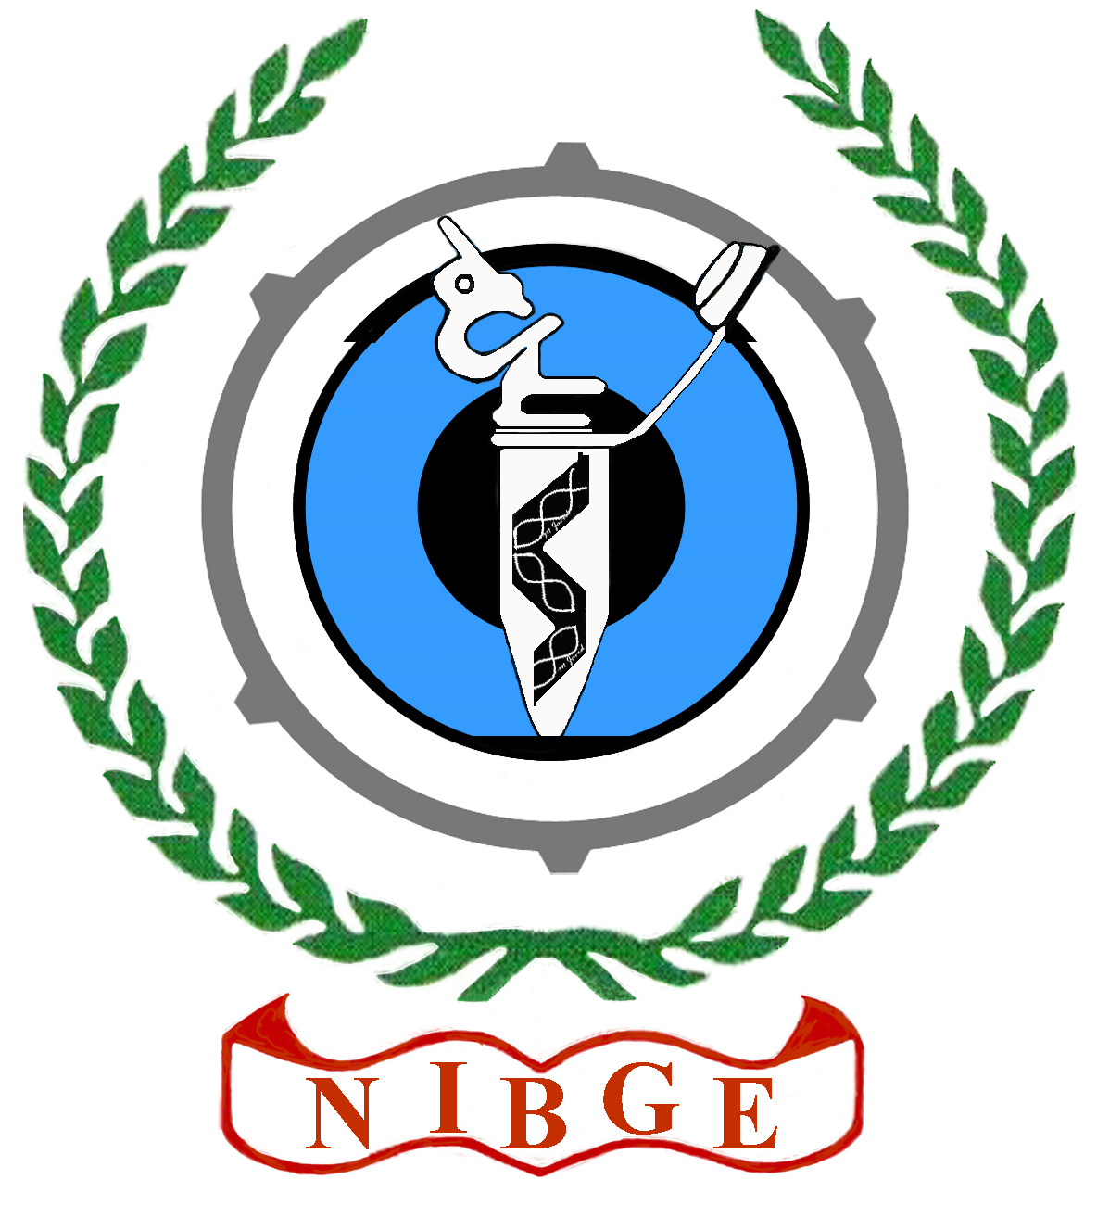

Advanced imagining techniques in biological & nanosciences
7th National Training Workshop
November 16-20, 2015, NIBGE, Faisalabad

Application Form No:
(To be filled in by NIBGE Office)

Application Form

Recent
Photograph
Name:
Father’s Name / Spouse Name:
Date of Birth:
Gender:
 |  |  |  |  | _ |  |  |  |  |  |  |  | _
NIC No:
Affiliated Institute:
Designation:
Address:
Ph: Fax: e-mail:
Academic Qualification:
Degree | Institution | Ranking | Year
B.Sc (Hons)
MS.c / M.B.B.S
Additional Qualification (If any)

Research Training Experience:

Required / Not Required
Local Transport, Accommodation & Meals

(Signature of Applicant) (Signature of the Applicant’s Head of Institute)

Note:
- Last date for the submission of forms is 10th Nov., 2015.
- Registration Fee and other charges may be deposited as cash or Bank Draft in the Name of Accounts Officer NIBGE, Faisalabad
- Send complete application form along with CV, copy of NIC & recent photograph to
The Course Organizer “Advanced Imaging Techniques in Biological & Nanosciences” National Institute for Biotechnology & Genetic Engineering, NIBGE, P.O. Box 577, Jhang Road, Faisalabad- PAKISTAN or
E. mail: asmaaslam2001@yahoo.com; Information is also available at www.nibge.org

- Last date of submission of forms is 1st Nov, 2011.
- Send complete application form along with CV to:
National Institute for Biotechnology & Genetic Engineering, NIBGE,
P.O.Box 577, Jhang Road, Faisalabad- PAKISTAN or e-mail: tsdnibge@gmail.com
- Application forms can also be downloaded from http://www.nibge.org

